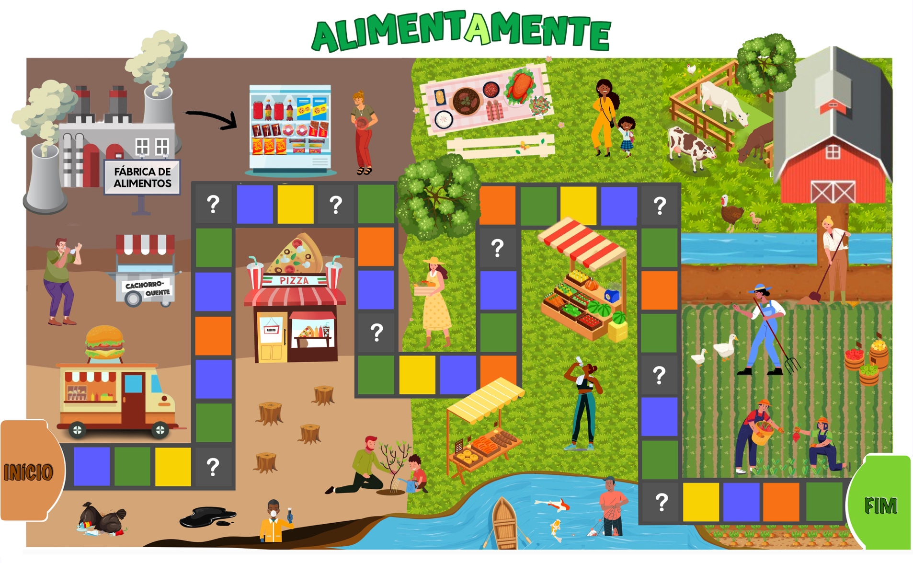

**Figure 1.** Final version of the board game.